PROJECT WORK

**PROJECT TITLE : Comprehensive Digital marketing for Hyundai motor company**

NAME : V Preethi Kumari

DEPARTMENT : Bsc BMC

COLLEGE : Vasavi Mahila Kalasala

UNIVERSITY : Rayalaseema University

MENTOR : Dr Hema Sundari

TEAM ID : LTVIP2025TMID21819



INTRODUCTION

In today’s digital landscape, having a robust online presence is crucial for automotive brands like Hyundai Motor Company to stay competitive and connect with their target audience. This comprehensive digital marketing strategy aims to enhance Hyundai’s online visibility, drive engagement, and ultimately, boost sales. Through a combination of brand study, competitor analysis, buyer persona research, SEO, content marketing, and performance measurement, this strategy will provide a roadmap for Hyundai to optimize its digital market.

Brandstudy, competitor analysis and buyers personal

A successful digital marketing strategy begins with a deep understanding of the brand, its competitors, and the target audience. This section focuses on the essential groundwork needed to inform and guide all subsequent marketing activities.

Research Brand Identity

The first step is to thoroughly research Hyundai’s existing brand identity. This involves analyzing the company’s mission, vision, values, and brand messaging. It’s crucial to understand how Hyundai perceives itself and how it wants to be perceived by its customers. This research should also cover the brand’s history, its unique selling propositions (USPs), and its overall brand equity. By gaining a clear understanding of Hyundai’s brand identity, we can ensure that all digital marketing efforts are aligned with the brand’s core values and objectives.

Competitor Analysis

Next, a comprehensive competitor analysis is essential. This involves identifying Hyundai’s main competitors in the automotive industry and analyzing their digital marketing strategies. Key areas to examine include their website design, SEO performance, social media presence, content marketing efforts, and online advertising campaigns. By understanding what competitors are doing well and where they are falling short, we can identify opportunities for Hyundai to differentiate itself and gain a competitive edge. The competitor analysis should also include an assessment of their brand messaging and how they are positioning themselves in the market.

Buyer’s/Audience’s Personal

Finally, developing detailed buyer personas is crucial for understanding the target audience. This involves creating fictional representations of Hyundai’s ideal customers, based on demographic data, psychographic information, and behavioral patterns. Each buyer persona should include details such as their age, gender, income, occupation, interests, motivations, and pain points. By understanding the needs and preferences of the target audience, we can tailor

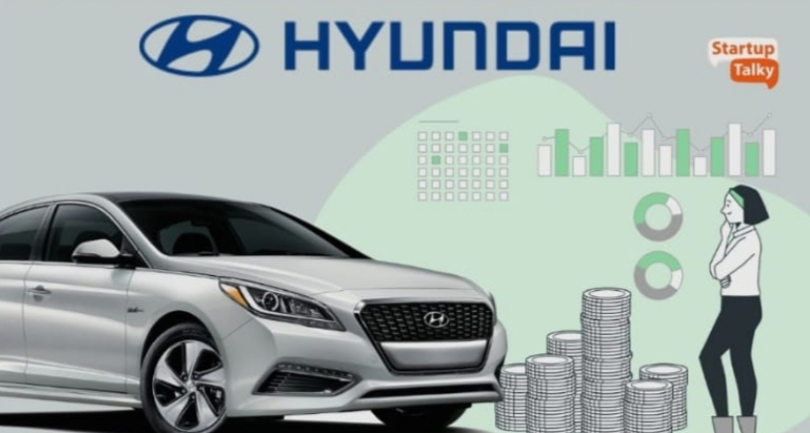

our digital marketing efforts to resonate with them effectively and drive engagement. We can use surveys and interviews to solidify these buyer personas.

SEO & Keyword Research

Search Engine Optimization (SEO) and keyword research are fundamental to driving organic

Traffic to Hyundai’s website and increasing its visibility in search engine results. This section

Outlines the key steps involved in optimizing Hyundai’s online presence for search engines.

SEO AUDIT



An initial SEO auditis necessary to identify areas for improvement on Hyundaï’s website. This

Involves analyzing the website’s structure, content, and technical aspects to ensure that it is

Search engine friendly. Key areas to examine include website speed, mobile-friendliness, site

Architecture, URL structure, and internal linking, The audit should also identify any broken

Links or errors that could be negatively impacting the website’s SEO performance. By

Addressing these issues, we can improve the website’s craw labiality and index ability, making it

Easier for search engines to find and rank its content.

Keyword Research

Keyword research is the process of identifying the keywords and phrases that Hyundai’s target

Audience is using to search for information online. This involves using keyword research tools

On-page optimization involves optimizing the content and HTMl source code of a page. It is

Search engine optimization applied directly to the website page that you’re trying to optimize

ebsite page that you’re trying to optimize

This includes optimizing title tags, meta descriptions, header tags, and I humage alt tags. It also

Involves creating high-quality, relevant content that is optimized for the target keywords. By

Optimizing these elements, we can improve the website’s ranking in search engine results

Pages (SERPs) and attract more organictraffic.Itis very important to do keyword research to

Determine the best keywords to use for a given page. This on-page optimization should also

Include an analysis of the website’s internal linking structure to ensure that users and search

To analyze search volume, competition, and relevance. The goal is to identify a mix of high-volume and long-tail keywords that can be used to optimize the website’s content and attract qualified traffic. Keyword research should also include an analysis of the competitive

Landscape to identify keywords that Hyundai’s competitors are targeting. We also need to look.

On Page Optimization

Engines can easily navigate the site.On-page optimization involves optimizing the content and HTML source code of a page. It is search engine optimization applied directly to the website page that you’re trying to optimize. This includes optimizing title tags, meta descriptions, headertags, and image alt tags. It also involves creating high-quality, relevant content that is optimized for the target keywords. By optimizing these elements, we can improve the website’s ranking in search engine results pages (SERPs) and attract more organic traffic. 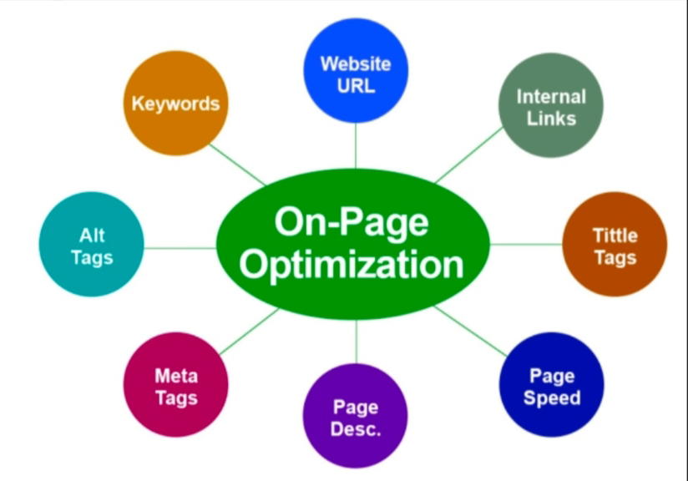Keyword research to determine the best keywords to use for a given page. This on page optimization should also include an analysis of the website’s internal linking structure to ensure that users and search engines can easily navigate the site.

Content Ideas and Marketing Strategies

Content is king in the digital world, and a well-crafted content strategy is essential for engaging with Hyundai’s target audience and driving conversions. This section outlines content ideas and marketing strategies to enhance Hyundai’s online presence.



Content Idea Generation & Strategy :

Generating fresh and engaging content ideas is crucial for attracting and retaining Hyundai’s target audience. This involves brainstorming a variety of content formats, such as blog posts, articles, videos, infographics, and social media updates. Content ideas should be aligned with the target audience’s interests, needs, and pain points.

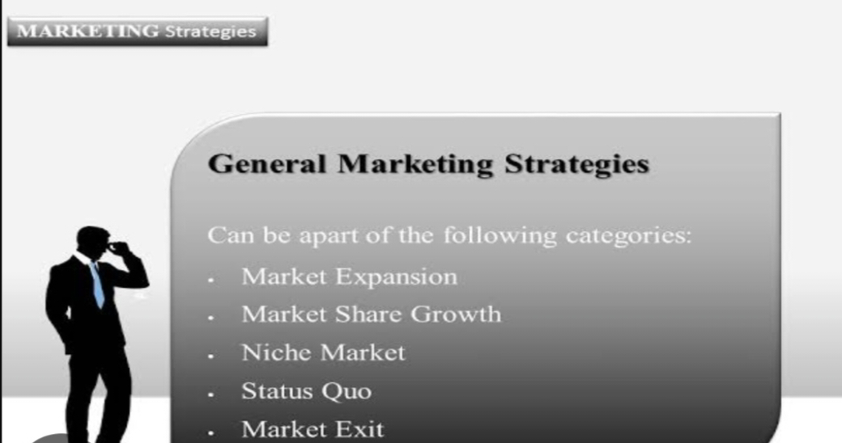

Marketing Strategies

A comprehensive marketing strategy is essential for reaching Hyundai’s target audience and achieving its business goals. This includes a mix of digital marketing tactics, such as SEO, social media marketing, email marketing, and online advertising.

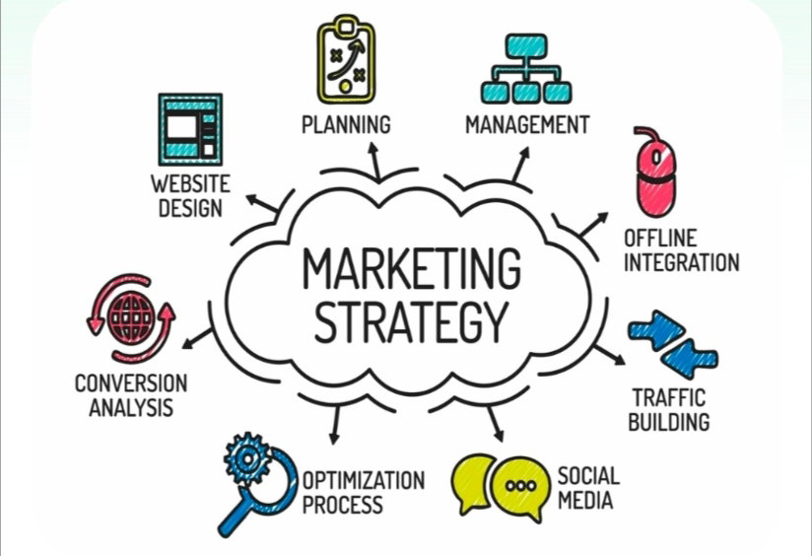

The strategy should be tailored to the target audience's preferences and behaviors, and it should be continuously monitored and optimized based on performance data. Social media marketing is a key part of the marketing strategies. It involves using social media platforms to connect with the target audience, build brand awareness, and drive traffic to Hyundai’s website. Social media campaigns should be developed to promote content, engage with followers, and generate leads.

Content Creation and Curation

The creation of high-quality content is key to reaching the target audience.

Post Creation

The posts that are created will be based on the needs of the audience. The audience will vary based on the platform and the media. It’s important to adapt the message to the platform as well as the target audience.

Good design and video editing can take content to the next level. A well-designed image or video can catch the eye of the reader and get them to read more. This design needs to be appealing and represent Hyundai’s brand well.

Social Media Ad Campaigns

Social media ad campaigns are an essential part of reaching the target audience. Social media ads are targeted based on various criteria such as demographics, interests, and behaviors.



Email Ad Campaigns

An email marketing campaign is a coordinated set of individual email messages that are deployed across a specific period of time with one specific purpose.



Email marketing is still very important. Email ads can be used to reach a targeted audience and promote products or services. The email ad campaign should be automated and personalized to the recipient. The effectiveness of the email ads should be measured.

Conclusion :

The comprehensive digital marketing project for Hyundai Motor Company aimed to enhance the brand's online presence, engage with the target audience, and drive sales. Through thorough research and analysis, the project identified areas for improvement and developed a tailored strategy to achieve the company's objectives.

Key words :

1. Content Marketing: Valuable, informative, and engaging content educated and entertained the target audience.

2. Email Marketing : Regular newsletters and promotional emails nurtured leads, encouraged conversions, and fostered customer loyalty.

For Future Improvement :

1. Continuous Website Optimization : Regularly monitor and improve website performance, user experience, and search engine rankings.

2. Social Media Analytics : Track social media metrics to refine the content strategy and engagement tactical.



would like to express my sincere gratitude for the opportunity to work on the digital marketing project for Hyundai motor company. Your guidance and support throughout the project were invaluable, and I appreciate the trust you placed in me.

Thank you for helping me develop my skills in digital marketing and for providing me with a platform to showcase my work.

Thankyou